The fifth period (self-check)  Teaching aims:  - Revise the contents of Unit 5.  - Ss can use the present progressive tense correctly.  Language points  - Revise the key words, phrases and sentences in this unit.  - To learn two new words: camera, bird  Key points and teaching difficulties.  Consolidate the present progressive tense.  Teaching steps:  - Warming-up and revision  Let one student take out a photo or a picture of his / her own and show it to the whole class, then he / she will ask some questions about the photo or the picture.  S1: Where is my father?  S2: He is…..  S1: What is he doing?  S3: He is…  S1: Is my mother doing…?  S4: No, she isn’t. She is …  Ask more Ss to come to the blackboard to do it.  - Presentation  Use two pictures and present the new words: camera bird  T: What is this?  S1: Sorry, I don’t know.  T: It’s a camera. We can use a camera to take a photo.  T: Look! What is it?  S2: It’s a bird.  T: That’s right. What is the bird doing?  S3: I think it is singing.  S4: I think it is flying.  - Complete the story  T: Look at the pictures Part 3. please complete the story and write the sentences in the blanks.  Check the answers:  What is he doing? He is looking at the birds.  What are they doing? They are talking.  What is the boy doing? He is running.  What is the boy carry? He is carrying a bag.  What is in the bag? It’s a camera.  What is the boy doing? He is taking a photo.  - Enjoy “ Just for fun!”.  (1)Divide the Ss into two parts and read the dialogue.  - Let Ss act out the dialogue.  5.Key words check ( work on 1 and 2)  （1）T: Let’s do Part 1, if you know the meaning, pronunciation and spelling of the vocabularies or phrases, please tick them. Try to remember the vocabulary that you don’t know.  T: After you finish Part 1, please write five new words in your vocab-builder.  （2）Have a dictation  read clean wait for at the pool happy  toy shopping at the mall TV show bird  - Grammar  (1).现在进行时态的基本结构  主语 + be动词 + 动词的现在分词  / | \  (is am are)  (2).动词现在分词的构成： 动词原形 + ing  read- reading play – playing eat – eating walk - walking  特殊变化： （1） 以“e” 结尾，去“e”加 ing  write – writing make – making take – taking  （2） 重读闭音节要双写结尾的辅音字母加ing  run – running swim – swimming  7.Grammar Test  一．写出下列单词的现在分词形式  eat write clean play run take swim  二． 按要求改写句子  1. He plays the guitar.( 用now改写句子)  He _______ ________ the guitar now.  2.They are talking on the phone.(划线提问)  _______ are they________?  3. She is cleaning the room.( 改一般疑问句，并做否定回答)  _____ ______ _______ the room?  ______, she ______.  4.They are swimming at the pool.（改否定句）  They _____ ______ at the pool.  5. I am singing a song. （ 改一般疑问句）  ______ ________ _______ a song?  三． 看图完成下列短文。  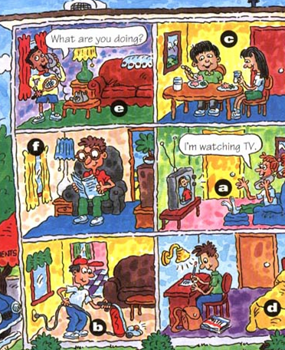  Hello, I’m a policeman. It’s nine o’clock now. I ______ walking around the happy apartment. On the first floor（层） Mike is ______ the room, Bill _____ ______ homework. On the second floor, Linda is ______ a book, Jenny _____ ______ TV and ______ on the phone. On the third floor Bob is ______ with Jenny ______ the phone, Dave and Mary _____ ______ dinner. All of them are very happy.  8． Homework  - Revise this unit.  - Finish the exercises. | 充分利用身边的材料进一步进行口语训练，确保学生口语的流利性和准确性。  用图片来呈现新的单词一目了然，非常直观，非常形象。同时也能引起学生的兴趣。  猜一猜，激发学生的发散性思维。  看图完成故事内容，以便检验一下学生书写的正确性。有条件的学校可以用实物投影，当场纠错让学生的印象更加深刻。  给学生一分钟的时间让他们单独进行自我检验。  在上课之前准备好听写本，当堂听写可以检验学生对本单元单词和词组的掌握情况。  在单元结束之时，对现在进行时进行总结，能帮助学生加深印象。必要时用中文来描述。  利用练习进一步巩固和检测学生对本单元内容的掌握情况。特别是练习三用一幅图画来完成短文，可以培养学生综合运用英语的能力。

